TROPICAL CYCLONE 3 - DAY OUTLOOK

Equator to 25S and 160E to 120W
Issue Time: 0400 UTC Saturday 10th November 2018.
Next Issue: 0400 UTC Sunday 11th November 2018.
Issued By: Tropical Cyclone Centre, RSMC, and Nadi.

Existing Tropical Cyclones:
Nil.

Likelihood of a tropical cyclone in the region in each of the next three days, TILL 13th November, 2018:

Sunday 11th November
The potential for formation of a Tropical Cyclone in the region is VERY LOW.
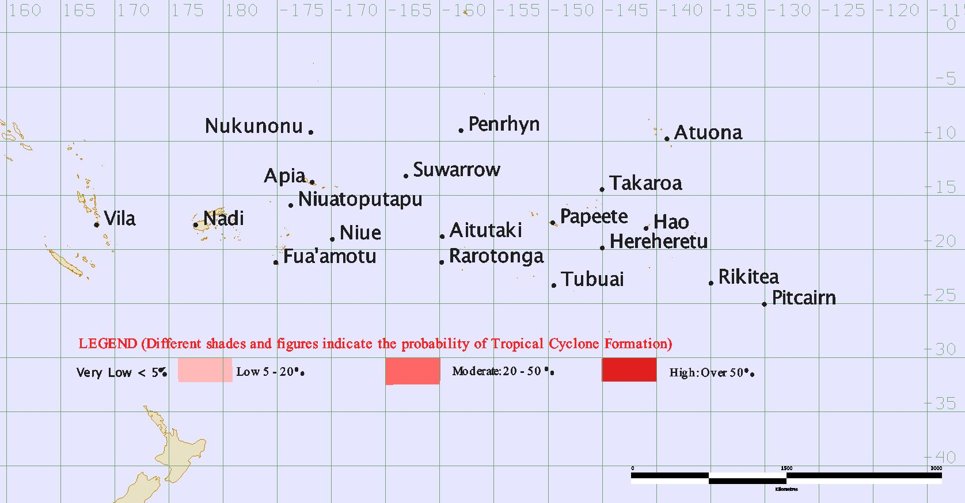

Monday 12th November
The potential for formation of a Tropical Cyclone in the region is VERY LOW.
Tuesday 13th November
The potential for formation of a Tropical Cyclone in the region is VERY LOW.

