FIJI METEOROLOGICAL SERVICE
7-Days Weather Outlook for Fiji
Issued from NWFC Nadi on Thursday 22nd June, 2017

WARNING: Nil.

SITUATION: An easterly wind flow prevails over the group. Meanwhile a trough of low pressure is expected to lie over the eastern parts of the group on Friday.

OUTLOOK
Western Division
DAY | WEATHER | WIND( Speed and Direction) | TEMPERATURE MAX/MIN(CELCIUS)
THU  22/06 | Fine apart from possible isolated afternoon or evening showers. Cool nights. | Moderate easterly. | 32/17
FRI  23/06 | Fine apart from possible isolated afternoon or evening showers. Cool nights. | Moderate south to southeast. | 32/17
SAT  24/06 | Fine. Cool nights. | Moderate south to southeast. | 32/18
SUN  25/06 | Fine. Cool nights. | Moderate southeast.  Fresh at times. | 31/17
MON  26/06 | Fine. Cool nights. | Moderate southeast.  Fresh at times. | 31/17
TUE  27/06 | Fine. Cool nights. | Moderate southeast.  Fresh at times. | 31/18
WED  28/06 | Fine. Cool nights. | Moderate southeast. | 31/18

Eastern Division
DAY | WEATHER | WIND( Speed and Direction) | TEMPERATURE MAX/MIN(CELCI US)
THU  22/06 | Fine apart from brief showers.  Cool nights. | Moderate easterly. | 31/19
FRI  23/06 | Cloudy periods with some showers | Moderate south to southeast. | 31/19
SAT  24/06 | Cloudy periods with some showers  Isolated heavy falls expected. | Moderate south to southeast. | 31/18
SUN  25/06 | Fine apart from brief showers.  Cool nights. | Moderate southeast.  Fresh at times. | 31/18
MON  26/06 | Fine apart from brief showers.  Cool nights. | Moderate southeast.  Fresh at times. | 31/18
TUE  27/06 | Fine apart from brief showers.  Cool nights. | Moderate southeast.  Fresh at times. | 31/18
WED  28/06 | Fine apart from brief showers.  Cool nights. | Moderate southeast.  Fresh at times. | 31/19

Northern Division
DAY | WEATHER | WIND( Speed and Direction) | TEMPERATURE MAX/MIN( CELCIUS)
THU  22/06 | Fine apart from afternoon or evening showers. Cool nights. | Moderate easterly. | 32/17
FRI  23/06 | Fine apart from afternoon or evening showers. Cool nights. | Moderate south to southeast. | 32/17
SAT  24/06 | Fine apart from afternoon or evening showers. Cool nights. | Moderate south to southeast. | 32/18
SUN  25/06 | Fine. Cool nights. | Moderate southeast.  Fresh at times. | 31/17
MON  26/06 | Fine. Cool nights. | Moderate southeast.  Fresh at times. | 31/17
TUE  27/06 | Fine. Cool nights. | Moderate southeast.  Fresh at times. | 31/18
WED  28/06 | Fine. Cool nights. | Moderate southeast. | 31/18

Central Division
DAY | WEATHER | WIND( Speed and Direction) | TEMPERATURE MAX/MIN( CELCIUS)
THU  22/06 | Fine apart from brief showers.  Cool nights. | Moderate easterly. | 31/18
FRI  23/06 | Cloudy periods with some showers | Moderate south to southeast. | 31/18
SAT  24/06 | Cloudy periods with some showers  Isolated heavy falls expected. | Moderate south to southeast. | 31/17
SUN  25/06 | Fine apart from brief showers.  Cool nights. | Moderate southeast.  Fresh at times. | 31/17
MON  26/06 | Fine apart from brief showers.  Cool nights. | Moderate southeast.  Fresh at times. | 31/17
TUE  27/06 | Fine apart from brief showers.  Cool nights. | Moderate southeast.  Fresh at times. | 31/17
WED  28/06 | Fine apart from brief showers.  Cool nights. | Moderate southeast. | 31/18

Rotuma
DAY | WEATHER | WIND( Speed and Direction)/SEA STATE | TEMPERATURE MAX/MIN( CELCIUS)
THU  22/06 | Fine apart from brief showers. | Moderate easterly. Moderate to rough seas. | 32/23
FRI  23/06 | Cloudy periods with some showers. | Moderate easterly. Moderate to rough seas. | 32/22
SAT  24/06 | Occasional showers and few thunderstorms. | Moderate southeast. Moderate to rough seas. | 32/22
SUN  25/06 | Cloudy periods with some showers. | Moderate southeast. Moderate to rough seas. | 32/22
MON  26/06 | Cloudy periods with some showers. | Moderate southeast. Moderate to rough seas. | 32/22
TUE  27/06 | Cloudy periods with some showers. | Moderate southeast. Moderate to rough seas. | 32/22
WED  28/06 | Fine apart from brief showers. | Moderate southeast. Moderate seas. | 32/23

Marine
DAY | WIND( Direction/Speed( knots)) | SEA STATE/SWELLS | VISIBILITY
THU  22/06 | Easterly winds 15 to 20 knots. | Moderate to rough seas. | Good
FRI  23/06 | South to southeast winds 15 to 20 knots. | Moderate to rough seas. | Fair
SAT  24/06 | Southeasterly winds 20, upto 25 knots through the passages. | Moderate to rough seas. Very rough through the passages. Moderate southerly swells. | Fair
SUN  25/06 | Southeast winds 20 to 25 knots. | Rough seas. | Fair
MON  26/06 | Southeast winds 20 to 25 knots, upto 30 knots through the passages. | Moderate to rough seas. Very rough through the passages. Moderate southerly swells. | Good
TUE  27/06 | Southeast winds 20 to 25 knots, upto 30 knots through the passages. | Moderate to rough seas. Very rough through the passages. Moderate southerly swells. | Good
WED  28/06 | Southeast winds 20 to 25 knots. | Rough seas. | Good

Note: Wind strengths taken from Beaufort scale. Strong = 22-27knots. Moderate Swells: 2-4 meters (6.5-13 feet)
Light = 5-10 knots 1 knot=1.85 kilometers per hour. Near Gale= 28-33knots. Heavy Swells: Greater than 4 meters ( > 13 feet)
Moderate = 11-16knots. Gale = 34-47knots. Visibility:

Fresh = 17-21knots. Swell Greater than 10km: Good
Low Swells: 0-2 meters (0-6.5feet) 5 to 10 km: Fair/Moderate
Less than 5km: Poor

THE NEXT REVIEW WILL BE ON MONDAY 26th JUNE, 2017.

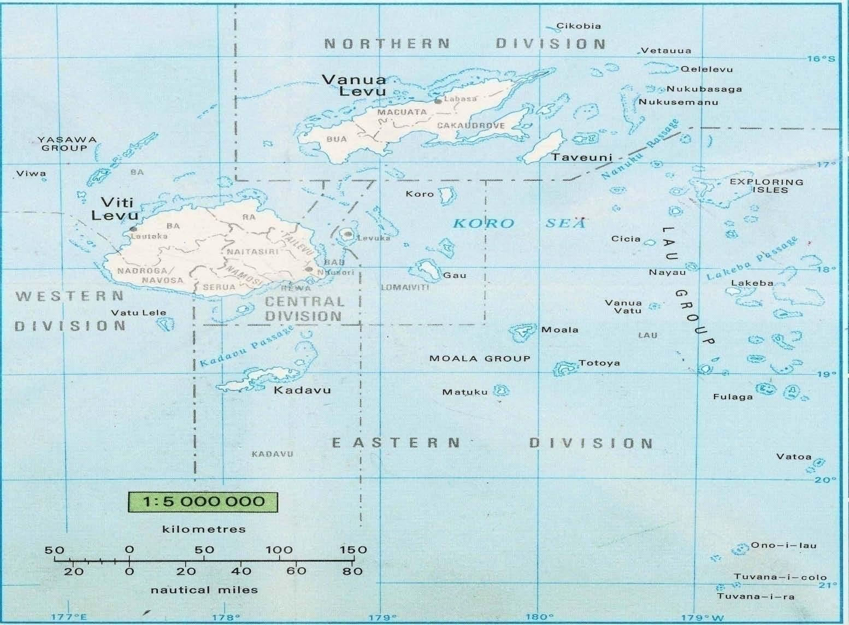

Fiji Map with Four Divisions Map (Source: Atlas of the South Pacific)

