TRAINING REPORT
NAME: Joape Golea.
PROGRAM: Safety Management System for Aviation Organizations.
POST: Technical Officer Class 1. DATE: 14/09/15 to 18/09/15.
MINISTRY: Infrastructure and Transport. COUNTRY: Fiji.
ORGANIZATION(FACILITATOR):
Mr.Jose Castellanos of Qualinet Surlatina Gestion.

He graduated in 1969 as an Airline Transport Pilot (ATP) from College of San Mateo, California, and holds an ATP license issued by the US Federal Aviation Administration (FAA) and diplomas in Social Communication, Business Administration and Project Management, Quality Management and Productivity, Organizational Communication, and Multimedia
Communication.
He began his aviation career in 1968, in LAN Chile, as a flight dispatcher and in 1971 as airline pilot, flying for Faucett, AeroPerú and Lan Chile (now LATAM Airlines Group).
As an airline executive he was appointed Technical Vice President and later Marketing Vice President of Aero Peru, the national airline of Peru, and Operations Quality Director for LAN Group (now LATAM Group).
As an aviation consultant and trainer has worked for International Air Transport Association(IATA) and currently is VP Aviation Division of QSL Consulting, a company with offices in Chile and Panama, specialized in Quality Systems, Environmental Systems, Safety and Occupational Health Systems, and Aviation SMS, IOSA, ISAGO, and International Management Standards implementation and audit.
He has worked with more than 250 customers implementing Quality, Environmental, Risk and Safety Management Systems. As an IATA accredited instructor, he has taught courses to international senior management audiences in 53 countries. For the aviation industry he is implementing SMS, SSP, BARS, ISBAO, IOSA and ISAGO management systems, worldwide.
FUNDING AGENCY: Civil Aviation Authority of Fiji (CAAF).

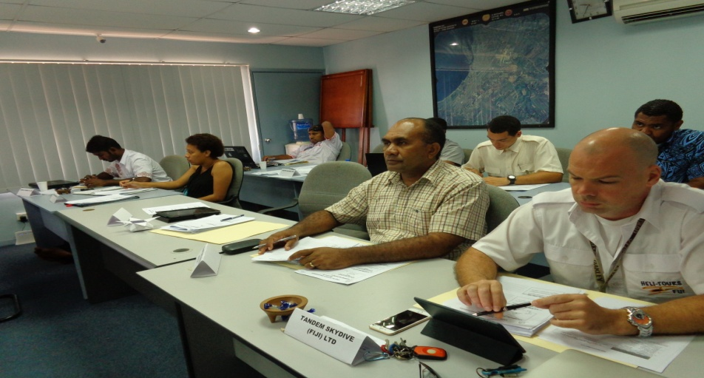

INTRODUCTION

The ultimate goal of aviation Safety Management System (SMS) is the prevention of aircraft accidents and incidents which are basically occurrences associated with the operation of an aircraft that takes place between the time any person boards the aircraft with the intention of flight until such time as all such persons have disembarked in which a person is fatally or seriously injured, the aircraft sustains substantial damage, or the aircraft is missing or completely inaccessible.

It is recognized that human activities or human-built systems cannot be guaranteed to be absolutely free from operational errors and their consequences. Therefore, safety is a dynamic characteristic of the aviation system whereby safety risks must be continuously mitigated.

The challenge for aviation organizations now is to develop not just a procedurally compliant Safety Management System (SMS) but one that actually “performs”, delivering a clear picture of our risks allowing us better control that can translate into value-adding results.

Hence, the course reflected on the new regulatory focus on managing safety at an organization level. It was focussed on developing and running a successful SMS as an essential and invaluable business tool and is designed to expand the competencies of those involved directly in safety management. It is based around the International Civil Aviation Organization (ICAO) SMS Framework Annex 19, the International Air Transport Association (IATA) and the Fiji State Safety Programme under the CAAF.

COURSE OBJECTIVES

The objective of the course is to understand the concepts, elements and key issues of a safety management system in an aviation organization, and to obtain the ability to develop and implement a “Safety Management System” according to ICAO standards and recommended practices, in order to increase safety in aviation operations.

The course is oriented to focus on safety performance, establishing safety system elements interaction, roles and responsibilities to ensure control of operations and safety outcomes (operate in a control environment and context)

CONTENTS

The main components of the Training are:

Session 1. Course Introduction
Session 2. Aviation Management and Context
Session 3. Aviation Safety Fundamentals
Session 4. SMS Elements and Strategy
Session 5. Safety Policy, Objectives & Documentation
Session 6. Safety Risk Management
Session 7. Assurance and Performance Evaluation
Session 8. Safety Promotion
Session 9.- Course Closure and Evaluation

METHODOLOGY

The course was conducted in an interactive manner.
The SMS course was conducted with mainly Power Point presentations and hands on exercises in groups of 4.
Internet access by CAAF allowed participants to visit some SMS websites as well..
There were also role plays, group and individual presentations as well as the question and answers .

OUTCOMES

The training met it’s outcomes by way of understanding:

-How aviation management has evolved through the years from the 1950’s to the 2000’s and the integration of Quality, Safety and Aviation Security systems in aviation management.

-The core of SMS is Risk Management which should be addressed through Safety Policies and Structure for Governance, Safety Assurance to control and Safety Promotion through internal communication and consultations in addition to competence evaluation and training .

-Enablers of the system are People, Competence and a robust Culture.

-The 12 Safety Management System processes and the integrated Aviation Management System (iAMS) map.

EVALUATION

The training was very informative in the sense that one understands the very important role the aviation meteorological services of FMS plays as one of the providers to safe flight operations not only at national level but to the whole Pacific region as well.

It challenges me to be more vigilant on every processes we undertake at NWFC concerning aviation weather and actively contribute to identifying ways we could continue to improve our products and services in conjunction with SMS.

RECOMMENDATION

Fiji Meteorological Service(FMS) should integrate SMS with our Quality Management System(QMS) already in place as per the ICAO Annex 19 and the Fiji State Safety Program.

Some concepts of SMS are already been practiced at NWFC in relation to our QMS but it is important to develop and implement the SMS to alleviate any perceived gaps between these two systems.

Civil Aviation Authority of Fiji as regulator has engaged Qualinet Surlatina Gestion(QSG) to see the development of their SMS. Two years ago, QSG with Mr Jose Castellanos had developed Air Terminal Services(ATS) integrated Aviation Management System(iAMS) which includes SMS and obviously this seems to be the world wide trend to all organizations or providers involved in flight operations.

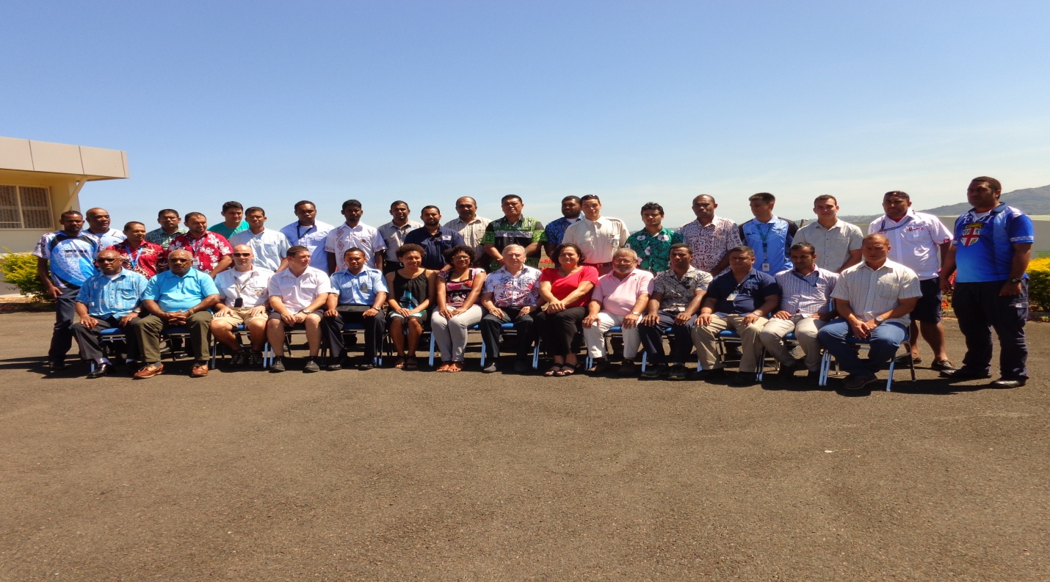
Group photo of participants of the SMS for Aviation organization training.

Joape Golea
Technical Officer I

