TROPICAL CYCLONE 3 - DAY OUTLOOK

Equator to 25S and 160E to 120W
Issue Time: 0400 UTC Friday 30 November 2012.
Next Issue: 0400 UTC Saturday 01 December 2012.
Issued By: Tropical Cyclone Centre, RSMC, Nadi.

Existing Tropical Cyclones:
Nil

Potential Tropical Cyclones:
Potential for tropical cyclone formation in the region for the next 3 days is very low.

Potential for New Tropical Cyclone formation to 1200UTC Monday 03rd December, 2012:

Saturday 01st December
Potential for tropical cyclone formation in the region is very low.

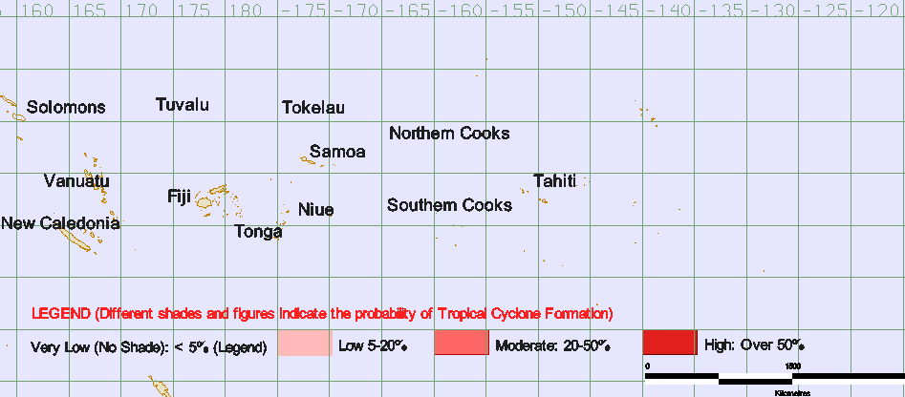.

Sunday 02nd December
Potential for tropical cyclone formation in the region is very low.

Monday 03rd December
Potential for tropical cyclone formation in the region is very low.

